# Project Mini bank project

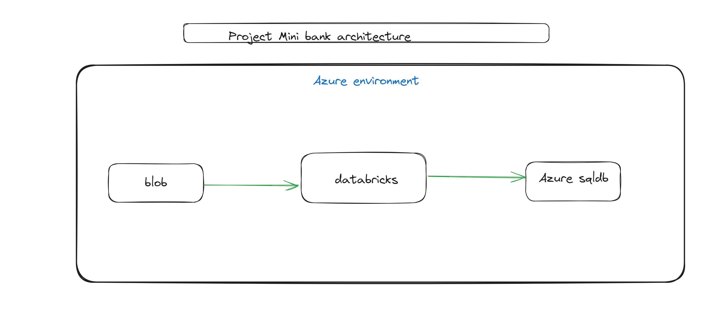

**Dataset: accepted_2007_to_2018Q4.csv**

**Notebook**: Mini_project_accept_data.ipynb

**Finale output in sql**

